Report submitted for Term project of 15 ECE302 Control system engineering

**Date**: 23/11/2020

**Title**: Insulin Injection system

**Group Members:**

1) CB.EN.U4EIE18049 SANJEEV S (Representative)

2) CB.EN.U4EIE18025 KALISWAR ADHISH R

3) CB.EN.U4EIE18037 NITIN THOPPEY M

4) CB.EN.U4EIE18046 ROHIDH M R

5) CB.EN.U4EIE18052 SENTHIL NATHAN M

Marks

|  |  |  |  |  |
| --- | --- | --- | --- | --- |
| S.no | Description | Excellent (10) | Good (5) | Not acceptable (0) |
| 1 | Design and analysis using CAD tools |  |  |  |
| 2 | Understanding of the problem (To be decided on seeing the quality of the report and if necessary, by interacting with the students) |  |  |  |
| 3 | Relationship of the problem to the topics taught in the syllabus |  |  |  |
| 4 | Contribution by all the team members (To be decided if necessary, by interacting with the students) |  |  |  |
| 5 | Report structure |  |  |  |
|  | Total marks (50) |  | | |
|  | Marks (20) |  | | |

**Problem statement:**

Insulin is an enzyme produced in β cells of the pancreas. Insulin is used in metabolism of carbohydrates, fats and proteins by increasing to absorption of glucose from blood. They are very useful for body to function. Risks involved by the body increases if blood sugar increases. So, the body naturally produces insulin as a measure to reduce the body sugar level. Diabetes mellitus is a problem that is associated with reduced insulin in our body. For People diagnosed with this problem, insulin is given externally through injection. Insulin injection regulates insulin according to the blood sugar level. The sugar level is tested using glucose meter. If there the insulin level is high, then the blood has decreased sugar level which is also dangerous. So regulated insulin levels are important for the body to function. The designed controller model regulates the insulin level needed to regulate blood sugar level for proper functioning of the body.

**Solution:**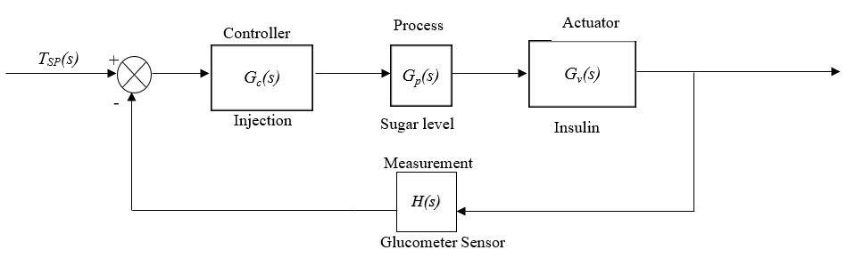

***Modelling****:*

Input = Sugar level Output= Controlled Sugar level

**Transfer function of the injection**

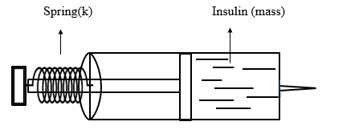

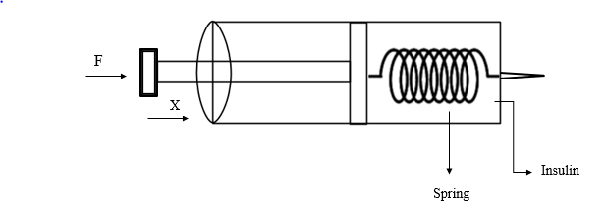

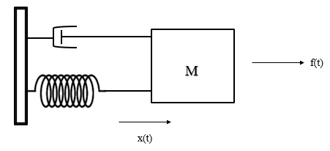 $$M\frac{ⅆ^{2}x}{ⅆt}+fv\frac{ⅆx}{ⅆt}+kx\left[t\right]=f\left(t\right)$$

$$\left[Ms^{2}+fv\left(s\right)+k\right]X\left(s\right)=F(s)$$

$$\frac{F\left(s\right)}{X\left(s\right)}=\frac{1}{mS^{2}+fvS+k}$$

Assume the following transfer functions:

$G_{C}\left(s\right)=\frac{1}{s}; G_{v}\left(s\right)=\frac{k}{s^{2}+4s+1}; H\left(s\right)=1$

***Analysis:***

**RH Table for Stability**

|  |  |  |
| --- | --- | --- |
| s3 | 1 | 1 |
| s2 | 4 | k |
| s1 |  | 0 |
| s0 | k | 0 |

Now,

For marginally stable,

$\frac{4-k}{4}=0, 4-k=0, k=4$

For stability,

$\frac{4-k}{4} >0;4>k≥0$

**Steady State error:**

From the above RH table, we choose the value of k=2, which is well within the range of 4>k≥0

Now,

$$G_{v}\left(s\right)=\frac{2}{{s(s}^{2}+4s+1)};H\left(s\right)=1$$

$$Kp = \lim_{s→0} \frac{2}{{s(s}^{2}+4s+1)} =∞$$

$$Kv = \lim_{s→0} \frac{s.2}{s\left(s^{2}+4s+1\right)} =2$$

$$Ka = \lim_{s→0} \frac{s^{3}.2.s}{s^{2}\left(s^{2}+4s+1\right)} =0$$

**Step input**: $\frac{1}{\left(\text{1+K}\text{P}\right)}\text{ =}\frac{\text{1}}{\text{∞}}\text{=0}$

**Ramp input**: $\frac{1}{Kv}$ = $\frac{1}{2}$ = 0.5 = 50% steady state error

**Parabolic input**: $\frac{1}{Ka}$ = $\frac{1}{0}$ = ∞

***Design:***

General lead compensator $=\text{C(s) = }\frac{\text{1+sτ}}{\text{1+sατ}}$

$\text{τ}$ = $\frac{\text{1}}{\text{ω}\sqrt{α}}$ α = $\frac{ 1-sin Φm}{1+sin Φm}$

With $G\left(\text{s}\right)\text{=}\frac{\text{2}}{\text{s}\left({\text{s}}^{\text{2}}\text{+ 4s+ 1}\right)}$, we have obtained a steady sate error for ramp input as 50%. Taking the stability of the system into consideration the steady state error for ramp input can come down only to 33%. If we try bringing down the error to less than 4% or 2%, the system becomes unstable which we don’t want.

**Case 1:**

System requirements: ess ≤ 0.04 for unit ramp input, Phase margin ≥ 45ο

→

Therefore, $Kv = k$

Since, $\text{e}\text{ss }\text{= 1/Kv and Kv} \text{=k}$ → Therefore, We, have, $\text{e}\text{ss }\text{= 1/Kv and e}\text{ss }\text{≤0.04}$

$$\text{1/k ≤} \text{0.04 or k} \text{≥25}$$

Let k = 30,

$$\text{G}\left(\text{s}\right) \text{=} \frac{\text{30}}{{\text{s}}^{\text{3}}\text{+4}{\text{s}}^{\text{2}}\text{+s}}$$

**Nyquist diagram:**

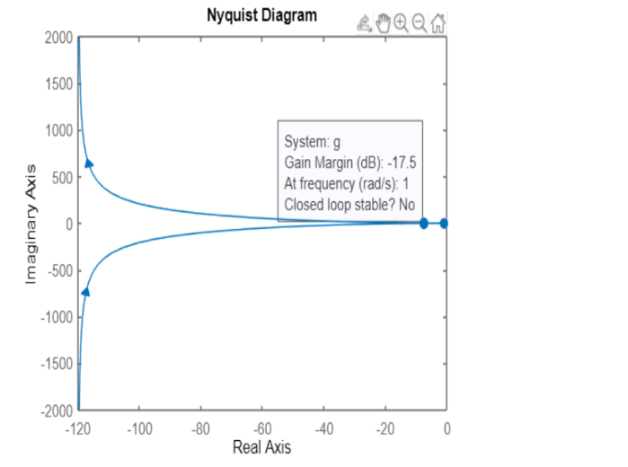 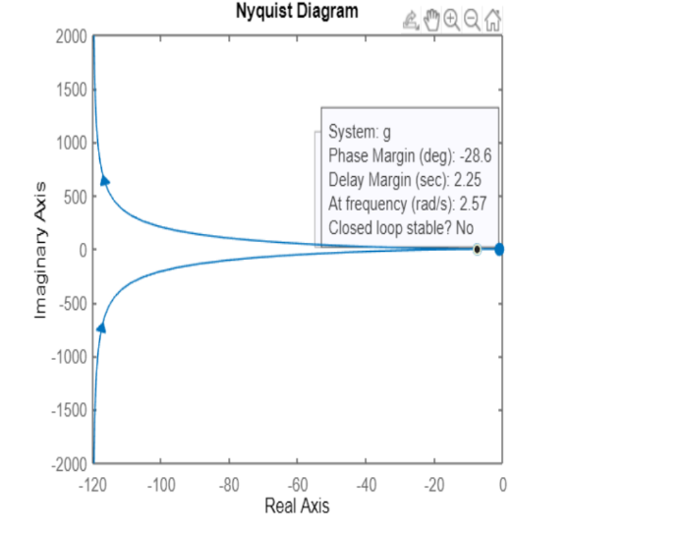

From the plot we can infer that the system is unstable for k=30 because the phase margin is negative. Hence lead compensator design cannot be done. Therefore, for system to stable to be we need to have k ranging from 0 to 3 wherein k=3 will possibly have the least steady state error for an unit ramp input.

**Uncompensated System response:**

Code:

% Defining numerator of the transfer function

num= [3];

%Defining denominator of the transfer function

den=[1,4,1,0];

% Defining the complete transfer function

g=tf(num,den);

% feedback

h=1;

% closed loop transfer function

T=feedback (g, h)

%To plot step response

step(T)

System Output:

Peak time and %Overshoot response Settling time

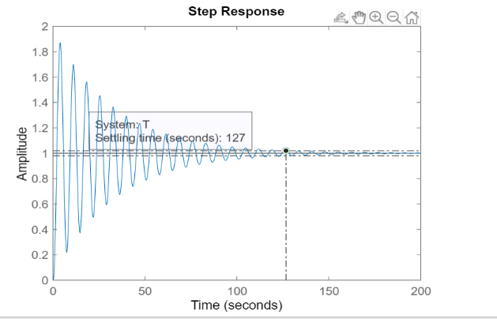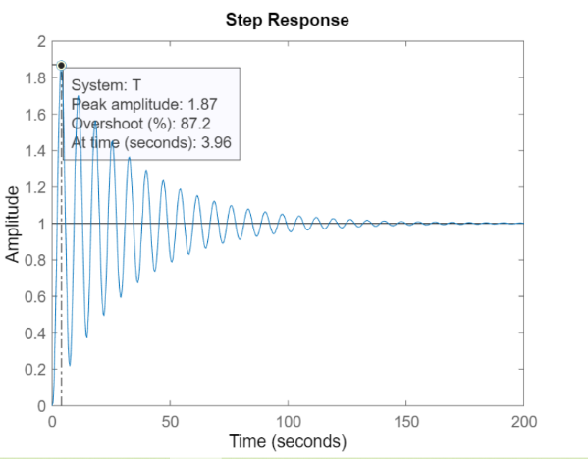

:

**Case 2:**

System specifications: steady state error ≤ 0.33 for unit ramp, Phase Margin ≥ 45ο

→

Kv = k and k = 3

(i.e.) $G\left(s\right)=\frac{3}{s\left(s^{2}+4s+1\right)}$

**Uncompensated System:**

Code:

% Defining numerator of the transfer function

num= [3];

% Defining denominator of the transfer function

den= [1,4,1,0];

% Defining the complete transfer function

g=tf(num, den);

% Plotting bode plot of the transfer function

bodeplot(g)

% Finding gain and phase margin of the transfer function

margin(g)

System Output:

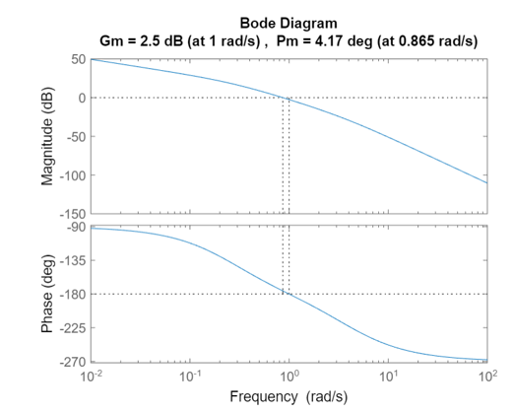

From the plot we can find that Initial phase margin = ΦS = 4.17ο

**Case 2(a):**

For Safety factor of 5:

Now, = R - S + x = 45 - 4.17 + 5 = 45.83ο

= 0.1646

M =10log(1/α) = 10log (1/0.1646) = 7.8357 dB

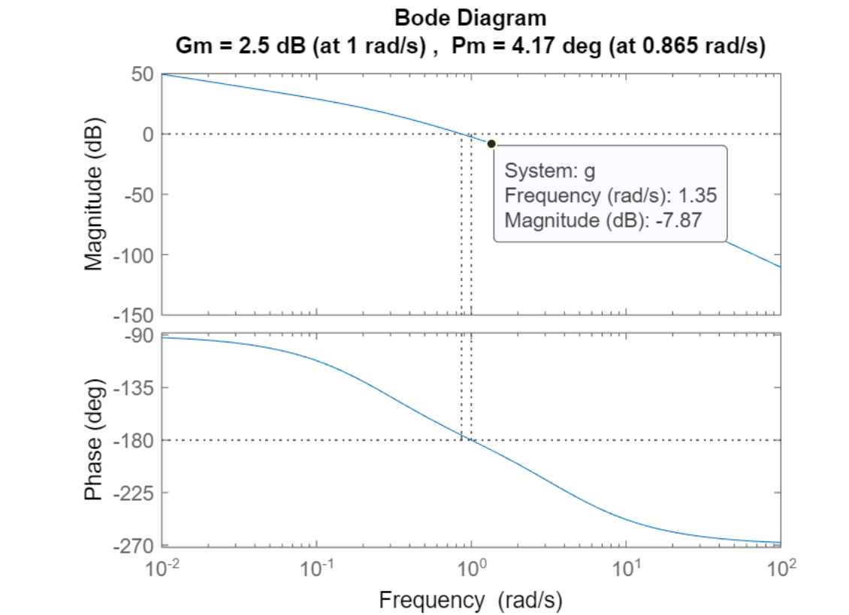

From the above plot we can find ω value which is the frequency at -7.8357 dB as 1.35 rad/s

$τ =\frac{1}{ω\sqrt{α}}$ = $\frac{1}{1.35×0.4057}$ = 1.8258

$\text{Transfer function =}\frac{\text{1+ sτ}}{\text{1+sατ}}$ = $\frac{1+1.8258s}{1+0.3005s}$

Compensated system = $\frac{1+1.8258s}{1+0.3005s}$ $×$ $\frac{3}{s\left(s^{2}+ 4s+ 1\right)}$ = $\frac{3+5.4774s}{0.3005s^{4}+ 2.202s^{3}+4.3005s^{2}+s}$

**Compensated System (a):**

Code:

% Defining numerator of the transfer function

num= [5.5774,3];

% Defining denominator of the transfer function

den= [0.3095,2.202,4.3005,1,0];

% Defining the complete transfer function

g=tf(num, den);

% Plotting bode plot of the transfer function

bodeplot(g)

% Finding gain and phase margin of the transfer function

margin(g)

System Output (a):

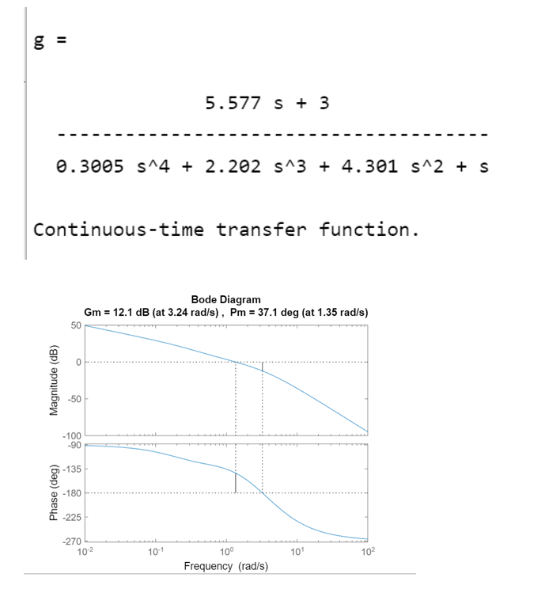

For safety factor of 5 the compensated system gives only a phase margin of 37.1ο , which is not the phase margin we desire. Therefore, we have to increase our safety factor to 15 to check whether we will get our desired phase margin.

**Case 2(b):**

For Safety factor of 15:

Now, = R - S + x = 45 - 4.17 + 15 = 55.83ο

= 0.0945

M =10log(1/α) = 10log (1/0.0945) = 10.2457dB

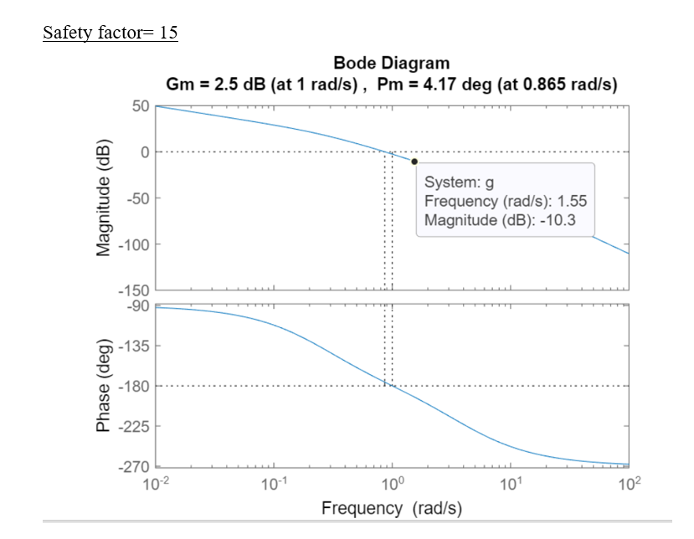

From the above plot we can find ω value which is the frequency at -10.2457 dB as 1.55 rad/s

$τ =\frac{1}{ω\sqrt{α}}$ = $\frac{1}{1.55×0.3074}$ = 2.0988

$\text{Transfer function =}\frac{\text{1+ sτ}}{\text{1+sατ}}$ = $\frac{1+2.0988s}{1+0.1983s}$

Compensated system = $\frac{1+2.0988s}{1+0.1983s}$ $×$ $\frac{3}{s\left(s^{2}+ 4s+ 1\right)}$ = $\frac{3+6.2964s}{0.1983s^{4}+ 1.7932s^{3}+4.1983s^{2}+s}$

**Compensated System (b):**

Code:

%Defining numerator of the transfer function

num= [6.2964,3];

%Defining denominator of the transfer function

den= [0.1983, 1.7932, 4. 1983,1,0];

%Defining the complete transfer function

g=tf(num, den);

% Plotting bode plot of the transfer function

bodeplot(g)

% Finding gain and phase margin of the transfer function

margin(g)

System Output (b):

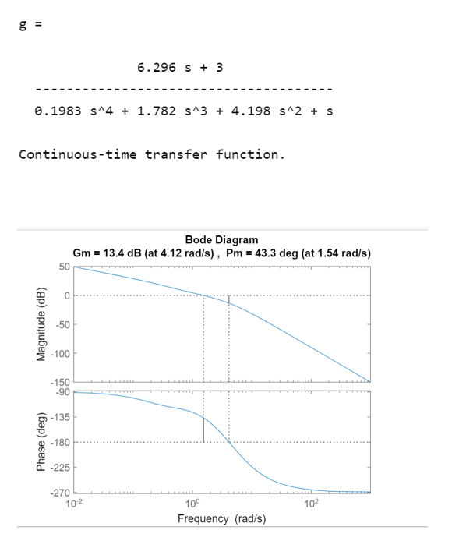

For safety factor of 15 the compensated system gives only a phase margin of 43.3ο , which is not the phase margin we desire.

**Compensated system response:**

Code:

% Defining numerator of the transfer function

num= [6.2964,3];

% Defining denominator of the transfer function

den= [0.1983,1.7,4.1983,1,0];

% Defining the complete transfer function

g=tf(num,den);

% feedback

h=1;

% closed loop transfer function

T=feedback (g, h)

%To plot step response

step(T)

System Output:

Peak time and %Overshoot: Settling time:

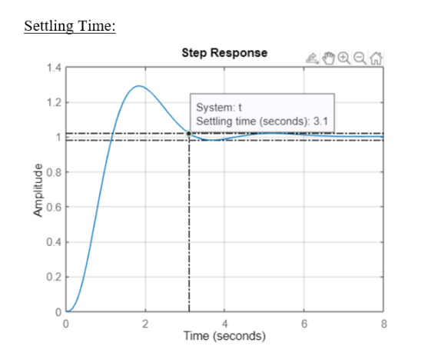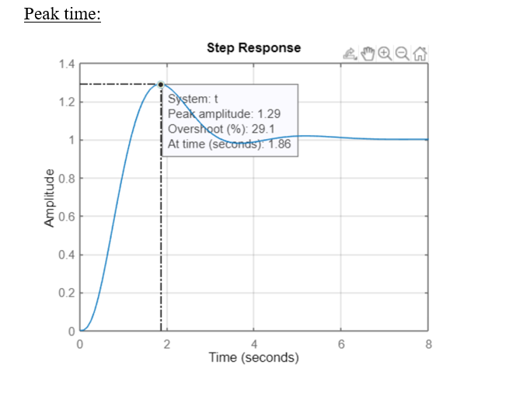

**Conclusion:**

Since the range of k for which the system to be stable is very small and that the maximum amount of safety factor is 15, a contradiction arises. If the maximum amount of supply factor can be extended a few values beyond the permissible limits, the desired phase margin of 45 can be obtained. We also can see that %Overshoot has decreased from 87.2% to 29.1% and settling time has decreased from 127s to 3.1s.

Work done by each member of the group:

1) CB.EN.U4EIE18025 Kaliswar Adhish R (Analysis)

2) CB.EN.U4EIE18037 Nitin Thoppey M (Modelling)

3) CB.EN.U4EIE18046 Rohidh M R (Design – Uncompensated System)

4) CB.EN.U4EIE18049 S Sanjeev (Design – Lead compensator)

5) CB.EN.U4EIE18052 Senthil Nathan M (Design – Lead compensator)